IMOS Impact Paradigm
Below is a starter Impact Paradigm for creating a framework for understanding the content you will work with throughout this course. For each type of material we will study in the course, you will reflect on the impact that material has made and currently makes on society.
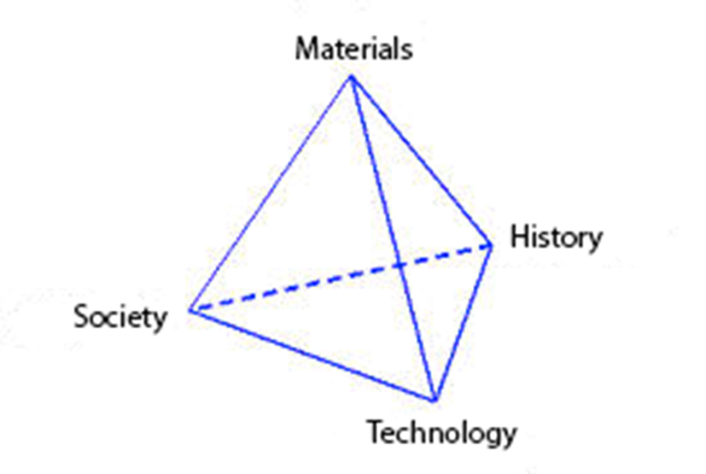

Materials

• What is the material of importance?

• What are the general properties of this material?

• What is the source of the material?

• What is the general abundance of the material?

• What are the unique (enabling) properties of the material?

Historical

• What is the first known use of the material?

• What people/groups were involved at the time of first use?

• At what time did the material become enabling?

• What discovery/development led to the material impacting society?

Technological

• What technology did the material enable?

• What role did the material play in the technology?

• What property of the material enables the technology?

• What are the limits of the technology?

• How do these limits relate to the properties of the material?

Societal

• In which realms of society did the materials development have an impact?

• What were the financial implications of the development?

• What were the health implications of the development?

• What were the political implications of the development? (e.g., was it used for war or peace?)

• What were the social implications of the development?

• What are the future societal needs with respect to the material/technology?

• To what extent will materials processing play a role in future impact?

• How will a break in the operational sequence affect how this material impacts society?

Throughout the course, you will be asked to add at least one question to the impact paradigm to any of the categories above.

