Instructions for opting into the PHY2053 course materials through UF All Access (Fall2022)

- Please visit www.bsd.ufl.edu/AllAccess --> click on the “opt In” tab or click “View Eligible UF All Access Classes” button on the bottom of the screenshot.
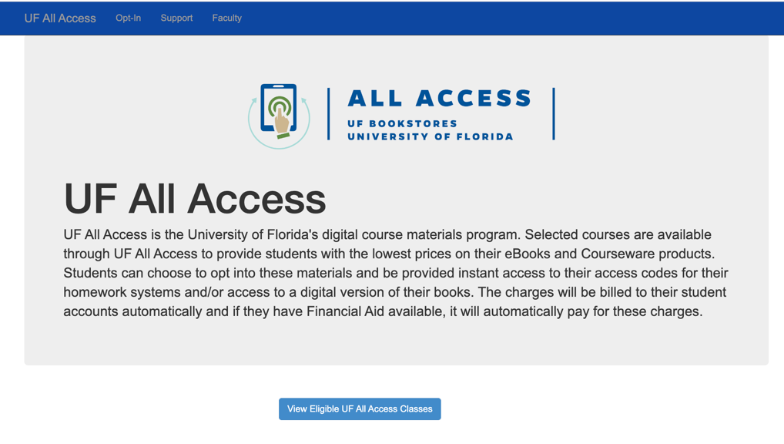

- You will then be directed to this page (see below). This page will display any courses you are enrolled in that are participating in UF All Access. For PHY2053, check the box in the opt-in column and click “opt in”. After clicking “opt in”, you will see the below page with a checkbox in the ‘opt in” column. In the code column, you will receive a unique message that reads:
Thank you for opting into your digital College Physics textbook and ExpertTA Access code for PHY2053. You will receive two confirmation emails sent to your @ufl.edu email with a registration link within 2 business days to active your account. The email will come from BryteWave. You will be able to access the eBook & the ExpertTA access code through the link provided in the emails.

**Note: I opted in at 7:30PM and the email was in my inbox at 11:34PM. We list 2 business days as a worst-case scenario.

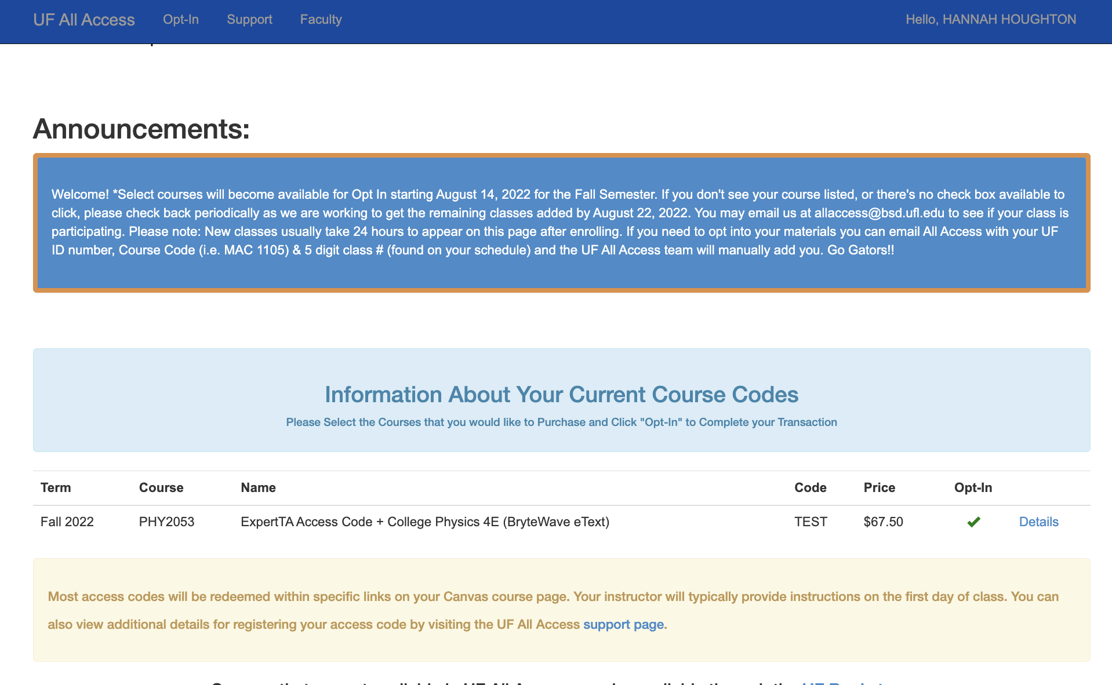

- Example Emails from BryteWave for both the Pearson eBook & ExpertTA Access code.

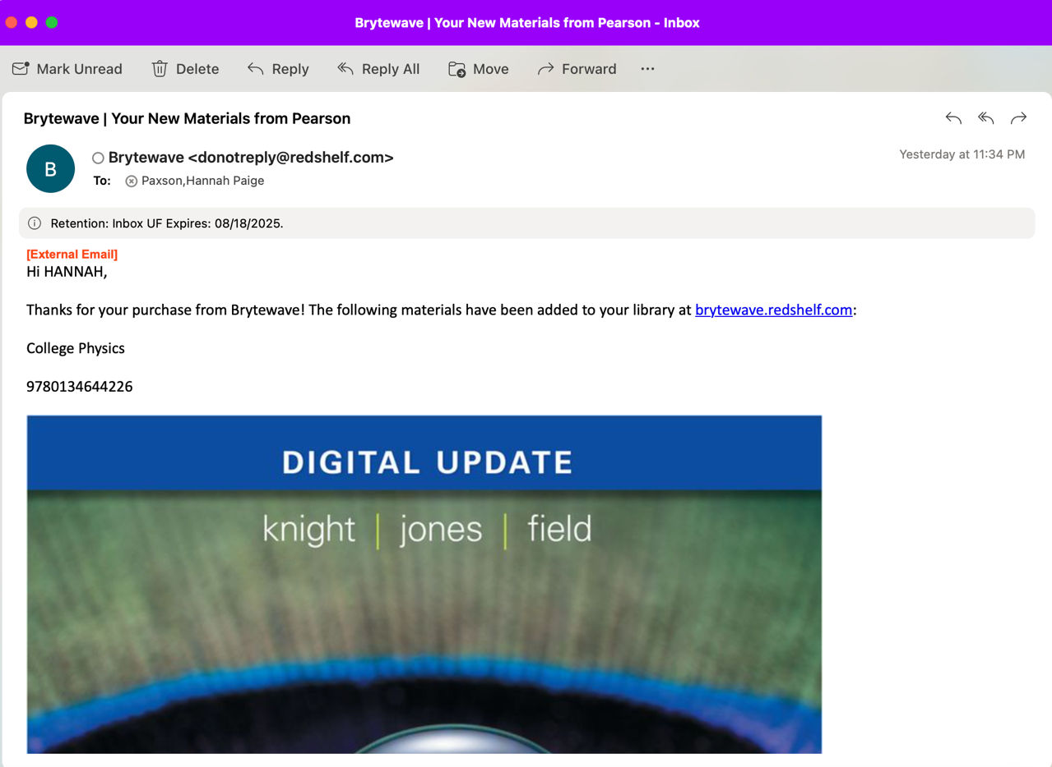

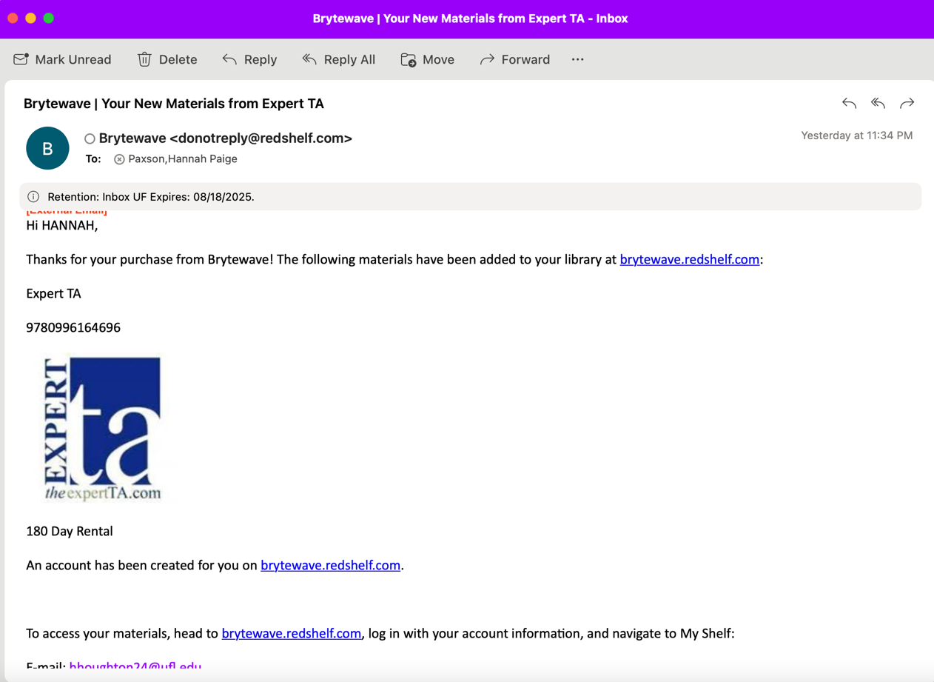

- The student will follow the links provided in the email which will bring them to brytewave.redshelf.com. They’ll click login and they are required to use their UF email. 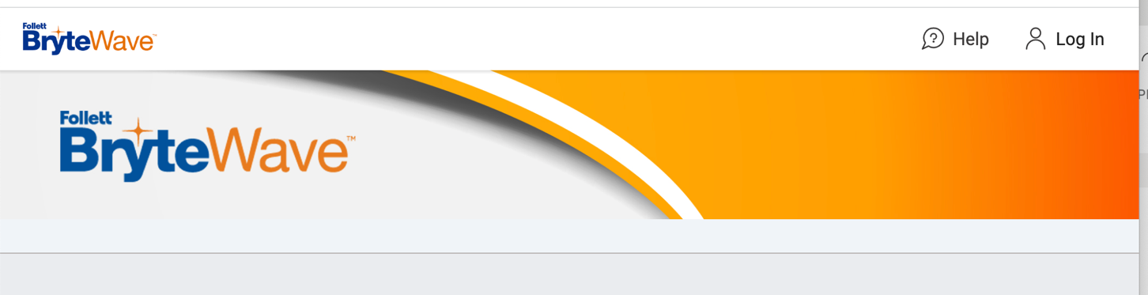

- After logging in, the student will see both the Pearson eBook and the ExpertTA available on their bookshelf (mine aren’t showing now because it expired this morning). They can basically click each book from the shelf, the Pearson eBook will allow them to instantly start reading the eBook, and when the click the ExpertTA book, it will present an Access code with instructions to redeem via the ExpertTA website.

