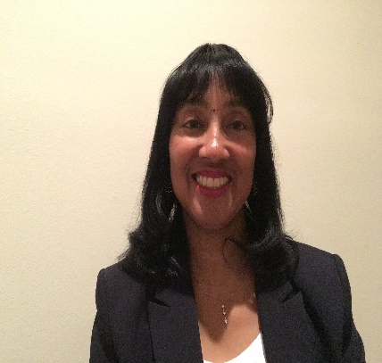
My name is Gwendolyn Ritter-Randolph, I was born in Charleston, South Carolina. I am a middle child with 2 older sisters and 2 younger brothers. My father was in the Air Force when I was younger and I attended seven elementary schools. When I was eleven, I went to live with my paternal grandmother in Charleston, South Carolina for three years while my oldest sister, who lived with my grandmother was in college. My father retired from the Air Force while we were living in Tampa, Florida so Tampa became our home. After returning to Tampa, I completed high school and went to college at the University of Florida where I completed my degree in Health Education with an emphasis in Patient Health Education. I completed my internship at North Florida Regional Hospital in Gainesville, Florida. After graduation I was hired as the first Health Educator at the University of South Florida Student Health Services. This job started out as a part-time position, but as demand for services grew transitioned into a full-time job. As the Health Educator I was responsible for providing health education, health promotion and wellness services to the university student population primarily, but also to the university community as a whole. I regularly served as a guest speaker at academic classes in the health education, sociology, public health colleges to name just a few. I also helped to develop and taught a “University Experience” academic credit course which was required of all freshmen admitted to the university. I also taught CPR, First AID for the American Red Cross and Smoking Cessations classes for the American Lung Association. I served as a Board Member to the Tampa AIDS Network, and the Hillsborough County Public Health Education Committee. While working at USF, I completed my Masters Degree in Public Health Degree (MPH) with an emphasis in Community Health Education. During my 16 years at USF I worked to grow my department to include 2 Senior Health Educators, A Registered Dietitian, Department Secretary, Student Assistants, Graduate Assistants and Peer Educators.
I feel that my transition to nursing was a natural progression in my professional career. My paternal Grandmother who I lived with for three years worked as a Private Duty Nurse. I remember her wearing all white and knowing that her job was important and had meaning. After working as a Health Educator for almost 16 years and having my youngest son, I knew that it was time for me to make a transition in my career. Nursing was the perfect fit for me because it would allow me to have a more hands on approach with people and to delve more deeply into their disease process and perhaps to allow me to help in the improvement in the quality of their health. I also found the flexibility of the nursing field to be appealing. I applied and was accepted to Hillsborough Community College in Tampa, Florida and graduated with an Associate of Science Degree in Nursing in May, 2001. I worked very hard in school and was recognized for both academic and clinical excellence by my instructors. I completed my boards and became a Registered Nurse in August, 2001. Since then I have worked as a RN on active and busy medical surgical units. I found that I had a passion for the medical surgical patient. I feel that it is one of the most challenging areas of nursing. Each patient’s history effects their admission diagnosis and makes each patient experience unique in how we provide nursing care. I have floated and then been requested to work on Progressive Care Units and in the Cardiac Cath Lab and in Cardiac Rehabilitation unit at my last hospital. I have been a Certified Medical Surgical Registered Nurse for 10 years. I am a Basic Life Instructor for the American Heart Association and provide BLS certification classes for health professionals to my hospital team members. I maintain my certification to administer the NIH Stroke Scale to patients on my unit when required for my nurses. I have also served as my units wound care resource nurse. I am currently a Charge Nurse on my unit. I participate in my hospitals Multidisciplinary Rounds Committee and do daily Leadership rounds on my unit to speak to the patients and family members. The ability to pursue a BSN degree at the University of Florida is a dream come true. I hope that I will be able to combine my love of health education and nursing into a increased leadership positons as a nurse or education manager. I look forward to what the future holds.

